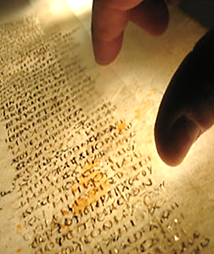
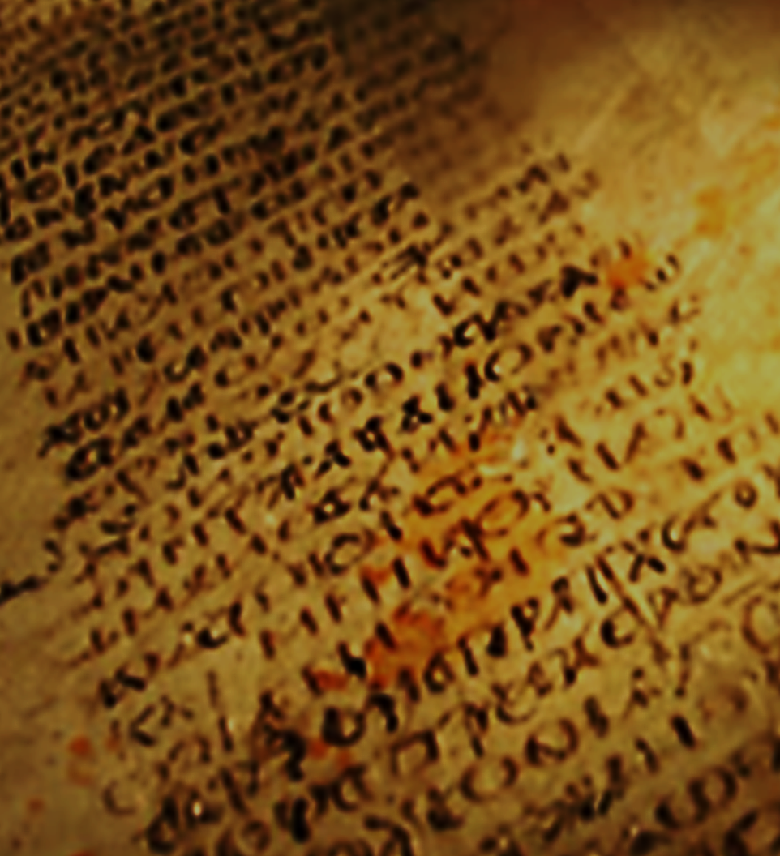

DID
JESUS
PREACH ISLAM
?
Muhammad solaiman

DID JESUS PREACH ISLAM?
Jesus (peace be upon him, PBUH) was sent like all the prophets of God to teach people that God is One and we should submit to His Law.
“The most important one answered Jesus, is this: ‘Hear, O Israel: The Lord our God, the Lord is one’” (Mark, 12:29).
“Do not think that I have come to abolish the Law or the Prophets; I have not come to abolish them but to fulfil them” (Matthew, 5:17).
However, after Jesus (PBUH), the anti-Christ Paul of Tarsus, who used to torture Christians, claimed his conversion to Christianity. In addition, he claimed to have had direct revelations from Jesus (PBUH), and hence, formulated a new Pauline Christianity.
According to Pauline Christianity, Jesus (PBUH) who was sent as a prophet of God, became the divine son of God who was sent as a ransom for the redemption of original sin of Adam and Eve. In addition, instead of fulfilling the law of God, Jesus (PBUH) was claimed to have freed Christians from it.
Regrettably, the Roman Emperor Constantine was inclined to Pauline Christianity and the Church adopted it to satisfy him and enforced it with his help. Therefore, what we have today is a Pauline Christianity and not the original Jesus’ Christianity
In this booklet, we provide, ample evidence, based on the Bible, that like all prophets, Jesus (PBUH) taught both the Oneness of God and the commitment to His Law, both of which are, by definition, called the religion of ISLAM.

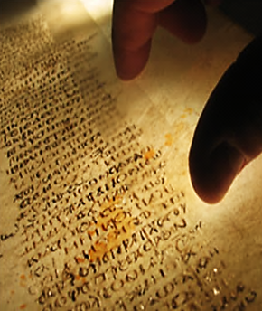

Copyright is reserved by the author except for those who want to distribute this booklet for free.
May God reward all those who contributed to writing, revising, amending, translating and printing this booklet.

Back of the front

IN THE NAME OF GOD, THE MOST GRACIOUS, THE MOST MERCIFUL
DID JESUS PREACH ISLAM?
Muhammad Solaiman
The International Commission of the Scientific
Signs in the Qur’an and Sunnah,
Taif Branch, Saudi Arabia

1. | Introduction | 1
2. | Islam | 2
3. | The Bible | 4
4. | Is Christianity based on Jesus’ teachings? | 7
5. | Tracing Jesus and his original teachings | 16
6. | Did Jesus practice Islam? | 23
7. | The conspiracy that falsified Christianity | 26
8. | Do you truly love Jesus? | 30
1. Introduction
The four Gospels of the Bible narrate Jesus’ life, teachings, and mission. However, if we go thoroughly through these Gospels, we will discover that the word “Christianity” is not mentioned. This raises an important question, “Wasn’t Jesus (peace be upon him, PBUH) sent to preach the religion of Christianity?”
The answer to this question is found in the Gospel of Matthew (5:17), where Jesus (PBUH) clearly declared the purpose of his mission:
“Do not think that I have come to abolish the Law or the Prophets; I have not come to abolish them but to fulfil them”.
Jesus (PBUH), in other words, was not sent by God to preach Christianity on the sense of a new different religion; his mission was to continue the mission of Moses (PBUH) and the chain of all the previous prophets of God.
The mission of all the prophets of God, including Jesus (PBUT), was to teach their people that there is One God who has no partners and to command them to obey Him and submit to His Law. Hence, Jesus (PBUH) was not an exception of the prophets. He was sent to the Jews, though they worshipped one God because they were not committed to the Law of God and therefore, he called them “the lost sheep of Israel” (Matthew, 15:24).
From where then, did the Triune nature of God (God the Father, God the son and God the Holy Ghost) come from? From where did original sin, and the suffering and death of God’s divine son on the cross, as a ransom for our original sin, come from? Were these notions preached by Jesus (PBUH) or other prophets? And are they found in the Gospels?
In this booklet, we will try briefly to answer these questions. We will use ample Bible-based evidence to demonstrate that unlike what has been propagated and taught about Jesus (PBUH), he absolutely preached One God and not a Trinity. In addition, all through his mission, he emphasised on the observation of the Law of God, he was originally sent to fulfil, and he was committed to it, even before his mission.
We will also discover that Jesus (PBUH) never mentioned an original sin or that he was sent as a ransom to suffer and to be crucified for this sin.
Finally, we will provide Bible-based evidence to prove that Jesus, like all the prophets of God (PBUT), preached Islam and how his message was twisted.
2. Islam
In order to understand the relationship between what Jesus (PBUH) preached and Islam, we need first to briefly know what Islam is.
2.1. What does Islam mean?
Islam means to submit to God alone without associating with Him any partner(s). This religion has been the Straight Path of God. It started with the birth of humanity; with Adam and Eve. They were commanded by God not to eat from a certain tree in the Paradise. In other words, God wanted them to submit and obey His Command or Law.
Since then, the obedience of the Law of God, which by definition is Islam, has been the core issue of the message of God conveyed by all His prophets and messengers like Noah, Abraham, David, Moses, Jesus and Muhammad (PBUT). Whenever people deviated from Islam, God sent them one of His prophets to remind them to hold to His Straight Path.
“Religion with God is Islam. Those to whom the Scripture was given (Jews and Christians) differed only after knowledge came to them” (Qur’an, 3:19).
Therefore, Jesus (PBUH) was sent to the lost sheep of Israel (Matthew, 15:24), when they deviated from the Law of God to get them back to God’s Straight Path, i.e. Islam.
In Islam, you admit that “there is only One God, and Muhammad is His messenger”. You also have to believe in the Angels of God, all the original revealed Books, all the messengers of God (like Noah, Abraham, Moses, Jesus and finally Muhammad, PBTH), and the last Day. Believing in One God is an instinct deeply rooted in everybody of us regardless of his religion. Therefore, even those who are polytheistic (believing in more than one god) usually believe in one major god, and associate other gods with him.
In Islam, associating partners with God is a major sin. God the Creator of the Heavens and the Earth; the All Mighty, and the All-Knowing does not accept any partner(s) to be associated with Him. This is quite clear all through the Bible and is affirmed by the Qur’an, revealed to the prophet Muhammad (PBUH).
“Do not worship any other god, for the LORD, whose name is Jealous, is a jealous God” (Exodus, 34:14).
“God does not forgive association with Him, but He forgives anything less than that to whomever He wills. Whoever associates anything with God has devised a monstrous sin” (Qur’an, 4:48).
Submission to God means to love Him and to reform your life according to His Will as taught to us by the Prophet Muhammad (PBUH).
On the other hand, literally the word Islam means both peace and submission to God. Worshipping God and submission to Him bring peace of mind, peace of the heart, peace with oneself, and peace with others. Submission to God is the Straight Path of God and the only way to achieve happiness in this life and the life to come.
2.2. What is unique about Islam?
Islam today is the only religion which has kept its faith, beliefs, rituals, and its holy book unchanged.
The Glorious Qur’an, which is the divine Book revealed to the Prophet Muhammad (PBUH), has been well preserved exactly as it was revealed. Once the verses of the Qur’an were revealed through Angel Gabriel to the Prophet Muhammad, they were memorised by heart by his followers and immediately recorded. Therefore, there is only one version of the Qur’an in its original language of revelation which is Arabic.
Today, millions or at least hundreds of thousands, of the 1.6 billion Muslims around the world memorise all the Glorious Qur’an by heart from the beginning to the end, regardless of their nationalities or native languages. Therefore, because the Qur’an has been authentically preserved, there is no need for another revelation or a new messenger of God.
On the other hand, unlike the writers of the Gospels, who ignored some details of Jesus' early life, and his experiences, all the minute details of Muhammad’s tradition; what he did and said, have been meticulously and fully preserved. Therefore, the Prophet Muhammad (PBUH) has set an example in all aspects of life for Muslims to follow. In fact, he has taught and demonstrated for us how we practically can live Islam.
3. The Bible
The Bible is the Christian scriptures, which consists of the Old and New Testaments. The scriptures of the Bible were written at different times by different authors in different locations over a period of about 1,500 years.
Most Christians believe that it has been accurately preserved over the ages and that the textual differences that exist are largely insignificant. However, Jeremiah, who was one of the major prophets of the Hebrew Bible (the Old Testament), had another opinion and he stated that “The false pen of the scribes has made it into a lie” (Jeremiah, 8:8).
Christian denominations (branches), which are over 33,000 (Christian Encyclopaedia, Oxford Univ. Press, 2nd edition, 2001) accept the Bible as a major source for the teachings of Jesus Christ (PBUH).
3.1. Books of the Bible
The Old Testament consists of 66 books which are based on the Hebrew Bible. It was transmitted orally for several generations before being committed to writing. Therefore, naturally, over the years, the books of the Old Testament evolved through countless translations, additions, and revisions.
The New Testament consists of 27 books which are the four Gospels of Matthew, Mark, Luke, and John, and the 23 other books. When the Church compiled them, it chose texts written in the old Koine Greek language and not the Aramaic Language of Jesus (PBUH).
The composition of the New Testament was officially settled at the Council of Carthage in AD 397. However, the exact text preserved in later manuscripts, may not necessarily be identical to those which existed in antiquity (See figure 1). No two copies of the discovered manuscripts agree completely throughout, and texts may even be contradictory.
Textus Receptus is a printed Greek New Testament published in 1516. It is the script which was translated into different languages like English (King James Bible), German, Spanish and Russian.
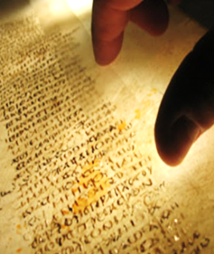 | Figure 1: According to the CNN, the oldest known Christian Bible (1,600-year-old) was found in a monastery in the Sinai desert in Egypt more than 160 years ago. It includes two books that are not part of the official New Testament and at least seven books that are not in the Old Testament. The New Testament books are in a different order and include numerous handwritten corrections. Important passages dealing with the resurrection of Jesus are missing.  (http://edition.cnn.com/2009/WORLD/europe/07/06/ancient.bible.online/index.html?_s=PM:WORLD#, retrieved 10, 2016).

3.2. Is the New Testament the divine work of God?
Let us read the following points before coming to conclusions.
- Jesus (PBUH) was not the writer of the New Testament.
- The writers of the New Testament were neither disciples nor eyewitnesses of Jesus (PBUH).
- The Gospels were not recorded soon after Jesus (PBUH) because early Christians mistakenly expected Christ’s second coming during their own lifetime. Therefore, the first recorded Gospel of Mark was written around the year 70 after him.
- The 27 books of the New Testament were affirmed as authoritative by the Church after almost four centuries, through three councils held between the years 363 and 397 after Jesus Christ (PBUH).
- The New Testament books chosen by the Church were written in old Greek language, instead of the Aramaic Language used by Jesus (PBUH).
- There are different interpretations of the old Greek language of the New Testament by different Christian denominations.
- The New Testament contains many contradictions (See figure 2 and please return to our book online “Restore your original religion, http://www.islamic-invitation.com/book_details.php?bID=1790). Would God inspire something contradictory?
- On April 24, 1870, the first Vatican Council approved additions to Mark (v.16:9-20), Luke, (22:19b-20, 43-44) and John, (7:53-8:11), which are not present in earlier manuscripts (https://en.wikipedia.org/wiki/Development_of_the_New_Testament_canon#cite_note-116). We may, therefore, conclude that the Bible was subjected to involuntary and intentional alterations as the Vatican did in its first Council.
3.3. A confession of some Christian Scholars
The scholars, who edited the New American Bible, have made frank confessions in their introduction of the edition of 2011. Below we summarise some of them. The Italic sentences are taken as they are from their introduction.
- “The Bible is God’s word and man’s word”.
- “Some authors chose existing folk tales and even beast fables to bring out their point”.
“And I stood upon the sand of the sea and saw a beast rise up out of the sea, having seven heads and ten horns” (Revelations 13: 1).
- “The sacred writers attribute quite a number of human characteristics to God”. This is “conditioned by time and culture”.
- The one who grabs a Babylonian baby and dashes it against a rock in Psalm (137:8-9) is blessed. “The feeling, the thought, the total poem is inspired (guided) by God, though it is not necessarily the revealed truth”!
“O daughter of Babylon, you devastated one … blessed is the one who takes your babies and smashes them against the rocks!” (Psalm 137:8-9).
- The description of the heavens and the earth in Genesis, Chapter 1, is not necessarily a true description. It is conditioned by the time and the culture in which it was written.
- “Reading the Gospels, one should distinguish historical facts from theological elaboration”.
- “It is difficult to know whether the words or sayings attributed to Jesus are written exactly as He spoke them”.
- The genealogy of Jesus in Matthew (1:1-17), is not an absolutely true genealogy.
- Matthew tells us that baby Jesus was taken to Egypt. This is not necessarily true. Matthew placed Jesus in Egypt to convince his readers that Jesus was the real Israel.
Figure 2: The Bible is full of contradictions. The following are just three examples told about the crucifixion of Jesus (PBUH).
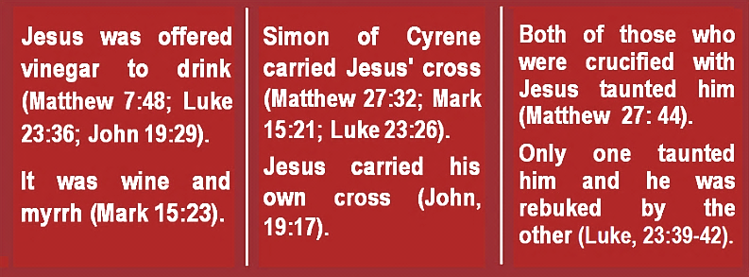

4. Is Christianity based on Jesus’ teachings?
Christians are told that the religion is based on the teachings of Jesus (PBUH). However, this is not true, because, many of today’s Christian’s beliefs and practices are not based on the Bible and the teachings and practices of Jesus (PBUH).
4.1. Deviations in beliefs
We will discuss only three core concepts of beliefs which are accepted by most Christians including Catholic, Protestant and Orthodox Churches. These concepts are the freedom from the Law of God, the Trinity, and Original Sin.
4.1.1. Freedom from the Law of God
As mentioned before, the submission and application of the Law of God are highly important right from the time of the creation of Adam and Eve. God commanded them not to eat from a certain forbidden tree. When they disobeyed His command (Law), they both were punished for their disobedience by sending them to the Earth.
To make sure that mankind would be committed to God’s Law. God sent a succession of prophets, who guided their people to the Law of God and commanded them to obey and follow it.
The importance of the commitment to the Law of God is demonstrated in the following verses from both the Old and the New Testaments.
“It pleased the Lord for the sake of his righteousness to make his law great and glorious” (Isaiah, 42:21).
“And it is easier for heaven and earth to pass, than one tittle of the law to fail” (Luke, 16:17).
“I tell you the truth, until heaven and earth disappear, not the smallest letter, not the least stroke or a pen, will by any means disappear from the Law until everything is accomplished” (Matthew, 5:18).
“None of those who call me ‘Lord’ will enter the kingdom of God, but only the one who does the Will of my Father in heaven” (Matthew, 7:21).
It is not enough to know the low and not to apply it. That is why Jesus (PBUH) was angry with the scribes and Pharisees who knew the Law of God, but they did not apply it. Jesus (PBUH) considered that a hypocrisy. He wanted his followers to respect the Law of God both in action and spirit. Was there any point of blaming the scribes and the Pharisees for their hypocrisy, with regard to the Law, if Jesus’ mission was to exempt them from it?
“You also outwardly appear righteous to men, but inside you are full of hypocrisy and lawlessness” (Matthew, 23:25-28).
Jesus (PBUH) also made the commitment to the Law as a sign of his love.
“If you love me, keep my commandments” (John, 14:15).
The Keenness of Christ (PBUH) that his followers would be committed to the Law of God made him, even though he is full of love, to curse those who do not apply it.
“No! But this mob that knows nothing of the law - there is a curse on them” (John, 7:49).
“Cursed be anyone who does not confirm the words of this law by doing them. And all the people shall say, Amen” (Deuteronomy, 27:26).
“The example of those who were entrusted with the Torah, but then failed to uphold it, is like the donkey carrying works of literature. Miserable is the example of the people who denounce God’s revelations. God does not guide the wrongdoing people” (Qur’an, 62:5).
Ironically, not only did Paul claim that Christ has set the Christians free from the Law of God, but he also considered God’s Law and Jesus Christ (BUH) as curses for us.
In addition, as previously mentioned Paul frankly claimed that his version of Christianity was better than Jesus’ Christianity and considered both the Law of God and Law of God and Jesus Christ (PBUH) as curses.
“For sin will have no mastery over you, because you are not under law but under grace” (Romans, 6:14).
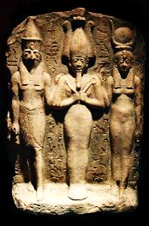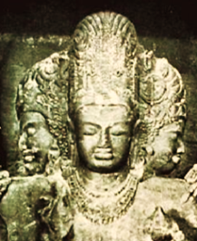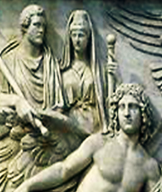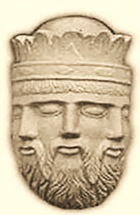
Egyptian Trinity | Indian trinity | Greek Trinity | Viking Trinity
Figure 3: Examples of triune gods, which preceded the Trinity.

“Because through Jesus Christ the law of the Spirit who gives life has set you free from the law of sin and death” (Romans, 8:2).
“Therefore, let us leave the elementary doctrine of Christ and go on to maturity, not laying again a foundation of repentance from dead works and of faith toward God” (Hebrews, 6:1).
“All who rely on observing the law are under a curse, for it is written: ‘Cursed is everyone who does not continue to do everything written in the Book of the Law’” (Galatians, 3:10).
“Christ redeemed us from the curse of the law by becoming a curse for us, for it is written, ‘Cursed is everyone who is hanged on a tree’” (Galatians, 3:13).
Does it make sense to claim to love Jesus (PBUH), and yet follow Paul, who taught a radically different religion and abolished the Law of God?
4.1.2. The doctrine of the Trinity
According to the Trinity, God is three distinct, eternally co-existing and co-equal persons; the Father, the Son (Jesus Christ), and the Holy Spirit. The three persons are distinct, yet they are “one substance, essence, and nature”.
The Trinity was debatable in several councils before being officially adopted several centuries after Jesus (PBUH). In 325, the Council of Nicaea adopted the Trinity and the notion that Christ is “God of God, Light of Light, very God of very God, begotten, not made, being of one substance with the Father.” In 381 the Council of Constantinople defined and affirmed “the Holy Spirit” which is the third part of the Godhead.
According to the International Standard Bible Encyclopaedia, “the ‘Trinity’ is a second-century term found nowhere in the Bible. The Church Since Adam was created and for thousands of years till the advent of Jesus (PBUH) there was never a hint of a divine son of God and a divine Holy Spirit as parts of a triune Godhead. On the contrary, God all through the Old Testament affirms that He is absolutely One God. In addition, the term “Trinity” was never mentioned by Jesus (PBUH) in the Gospels.
“You may know and believe Me and understand that I am He. Before Me, there was no God formed, neither shall there be after me” (Isaiah, 43:10).
“How can you believe since you accept glory from one another but do not seek the glory that comes from the only God?” (John, 5:44).
“Now this is eternal life: that they know you, the only true God, and Jesus Christ, whom you have sent” (John, 17:3).
Would we believe what God and Jesus said about the absolute Oneness of God, or what Paul or the Church say about His triune nature?
“They have taken their rabbis and their priests as lords instead of God, as well as the Messiah son of Mary. Although they were commanded to worship none but The One God. There is no god except He. Glory be to Him; High above what they associate with Him” (Qur’an, 9:31).
4.1.3. Original sin
According to Paul, through one man (Adam), sin entered the world in the form of original sin. Original sin is harboured in every descendant of Adam; the entire human race inherits it from the very moment of conception.
“For as by one man’s (Adam’s) disobedience many were made sinners, so by one man’s (Jesus’) obedience many will be made righteous” (Romans, 5:19).
On the contrary to that notion, the Qur’an teaches us that there is no original sin because God is forgiving and both Adam and Eve repented and were forgiven.

“Then Adam received words from his Lord, so his Lord pardoned him (accepted his repentance). He is very Relenting, the Most Merciful” (Qur’an, 2:37).
4.1.3.1. Original sin is an innovation
Both Islam and Judaism teach that humans are born free from sins. Jesus himself (PBUH) never mentioned anything about Original Sin. The doctrine of Original Sin was adopted in the 2nd century by the Church and it is based on the teachings of the Epistles of Paul.
“For the wages of sin is death, but the gift of God is eternal life in Christ Jesus our Lord” (Romans, 6:23).
“That Christ died for our sins according to the scriptures; and that he was
buried, and that he rose again the third day according to the scriptures” (1Corinthians, 15:3-4).
4.1.3.2. Original sin contradicts the teachings of Jesus
Jesus (PBUH) never mentioned anything about original sin of Adam and Eve and he never mentioned that he was sent to suffer and to die on the cross to redeem our original sin.
The following verse of John’s Gospel was claimed to refer to the original sin and redemption.
“The next day John sees Jesus coming unto him, and says, Behold the Lamb of God, which takes away the sin of the world” (John, 1:29).
However, this verse was stated by John and not by Jesus (PBUH). In addition, it could be understood in the sense that, like all prophets, Jesus (PBUH) was sent to take away sins of people by guiding them to God’s Straight Path.
According to that Law of God, which Jesus (PBUH) was sent to fulfil:
“The son shall not bear the iniquity of the father, neither shall the father bear the iniquity of the son” (Ezekiel, 18:20).
In addition, Jesus (PBUH) emphasised that for God to forgive us we have to forgive others.
“And when you stand to pray, if you hold anything against anyone, forgive them, so that your Father in heaven may forgive you your sins” (Mark, 11:25).
“For if you forgive other people when they sin against you, your heavenly Father will also forgive you” (Matthew, 6:14).
“Forgive and you will be forgiven” (Luke, 6:37).
If our sins have been already forgiven through the crucifixion of Jesus (PBUH), what is the point of hoping to be forgiven by God?
4.1.3.3. Original sin contradicts God’s grace
According to Christian scholars, God's justice requires that there should be a payment of the penalty for sin. Therefore, “Jesus Christ (PBUH) was offered as the atonement for sins so that both the justice and the love of God have been maintained”. However, does Original Sin, as claimed, materialise the Justice and Grace of God?
Christian scholars believe that outside the Church there is no salvation, so those who are not baptised, whether adults or newborns, could not enjoy salvation.
Now, what would happen to all those people who lived for thousands of years, since Adam till the advent of Jesus Christ (PBUH) and what is the position of the newborns, who die before baptism? Are they entitled for the Grace of God? According to the Church, the answer is “No”.
Even though the Church suggests that hell of the newborns is a mitigated form called “limbo”, still they have been deprived of Heaven. In addition, Limbo of the Infants is not an official doctrine of the Catholic Church and it is not accepted by both the Eastern Orthodox and Protestant Churches.
On the other hand, the Eastern Orthodox Church lays much stress on the resurrected Christ's action of liberating Adam and Eve and other righteous figures of the Old Testament, such as Abraham and David, from Hades (Hell). Some Protestant scholars believe that those who died as believers prior to the crucifixion of Jesus resided in a place that is not Heaven, but not Hell. A place named Abraham's Bosom.
Is it fair for the righteous people, before Christ, to be deprived of Grace of God for thousands of years and be kept in a Bosom?
Original sin, which is based on Paul’s philosophical teachings, contradicts with God’s Passion, Kindness, Justice and Love. It is cruel enough to deprive today’s unbaptized newborns of the God’s Grace and contradicts with the teachings of Jesus Christ and all other prophets of God (PBUT).
Therefore, though, Pope Paul II was supposed to be one of the guardians of the notion of original sin, he denounced it (See figure 4).
4.2. Deviations in practices
Many worshipping rituals of Christianity were introduced by the Church long time after Jesus (PBUH). These rituals are utterly unbiblical and were influenced by the pagans of the Roman Empire in Europe, Africa and Asia. In other words, the Church “Christianized” some rituals of the surrounding pagan religions to attract them, as demonstrated in the following examples. Please return also to our book “Restore your original religion” (http://www.islamic-invitation.com/book_details.php?bID=1790).
4.2.1. Confession of Sins to a priest
The concept of confession of sins to a priest was not taught by Jesus (PBUH) in the Bible. God forgives all sins as we confess them directly to Him (1 John, 1:9). God does not need mediators between us and Him.
“Say, ‘O My servants who have transgressed against themselves: do not despair of God’s mercy, for God forgives all sins. He is indeed the Forgiver, the Clement’” (Qur’an, 39:53).
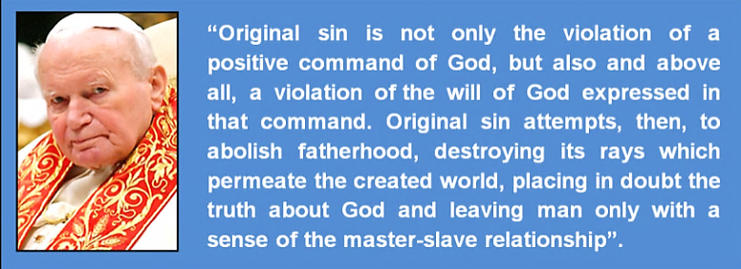
Figure 4: A quote from Pope Paul II in his book “Crossing the Threshold of Hope”, Random House, Inc., New York City, page 228, 1994.

4.2.2. Intercession of the saints
Eastern Orthodox, Oriental Orthodox and Roman Catholic Churches held the doctrine of the intercession of the saints.
Prayer to saints was borrowed from pagans to attract them to Christianity. Therefore, the Church simply replaced Roman pagan gods with the Christian saints. The intercession of saints was never mentioned by Jesus (PBUH) and contradicts the following verse of the Bible.
“Let no one be found among you who sacrifices their son or daughter in the fire, who practices divination or sorcery, interprets omen … or who consults the dead. For whoever does these things is detestable to the LORD” (Deuteronomy 18:10-11).
Logically, who has the authority to appoint someone as a saint? In addition, in order for a saint to hear all prayers directed to him, he should possess the attributes of omniscience and omnipresence, both of which make him an associate to God.
God is near to all of us and does not need saints as intercessors. He hears our prayers and forgives our sins, no matter how much or how big they are.
“And when My servants ask you about Me, I am near; I answer the call of the caller when he calls on Me. So let them answer Me, and have faith in Me, that they may be rightly guided” (Qur’an, 2:186).
4.2.3. Prayers to Mary
Catholics and orthodox pray to Mary as the Queen of heaven and mother of God. This was originally practised at the time of the Romans for goddess Isis of Egypt. The worship of Isis was combined with the worship of her husband, Osiris, and her son Horus who constituted an Ancient Egyptian trinity, that preceded the Christian Trinity by thousands of years.
Isis’ worship spread throughout the Greco-Roman world (Figure 5). For instance, there was an annual ancient Roman religious festival in honour of the goddess Isis at least until the year 416 AD. To attract Isis’ worshippers to Christianity the Church substituted her with Mary (PBUH). Therefore, the worship of Mary is not Biblical, has roots in pagan ancient Egyptian practices and was never taught by Jesus (PBUH).
4.2.4. Consumption of Christ's Body and Blood
In Eucharist (Holy Communion; Lord's Supper; the sacrament of sacraments), Christians eat bread and drink wine to symbolise Jesus’ body and blood. This practice has roots in Mithraism which was a popular religion in the Roman Empire in the 1st through 5th centuries AD.
According to Mithraism, their god Mithras was “present” in the flesh and blood of the bull, and when his followers consumed them, they were granted salvation. Therefore, the bull was replaced with Jesus Christ (PBUH), who is
considered by Christians as God in flesh and the bread and wine symbolise Jesus’ (PBUH) body and blood (Figure 6).

4.2.5. Festivals
To deceive and compromise with pagans so that they become Christians, the Church co-opted their festivals and gave them new Christian names.
- Christmas in Winter Solstice: Jesus was born in fall and not in winter. In winter solstice pagans used to celebrate the Day of Saturnalia which is the birthday of their unconquered sun god Sol Invictus. Winter solstice is also the birth date of the pagan god Attis and Mithras.
- Easter in spring equinox: Spring equinox is the time pagans had celebrations in honour of Ishtar the goddess of fertility.
- St. John's Day in summer solstice: Summer solstice is the time when pagans celebrated the fire festival or what is called Litha.
- St. Michael and All Saints in fall equinox: Fall equinox is the time of festivals of Dionysus, the festival of Pomona (the goddess of Rome of fruits and growing things), and the festival of Avalon (the festivals of the Wine and apple harvest).
Do you believe that Christian festivals and pagan festivals coincide by chance or this was deliberately planned by the Church?
5. Tracing Jesus’ original teachings
It is true that there were thousands of genuine records of the Gospels and
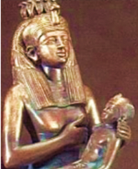 | 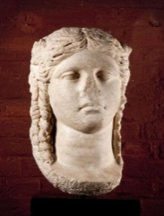 | 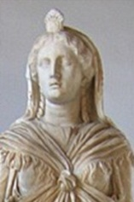
Isis nursing Horus | Isis, Nat. Archaeological Museum, Athens, Greece | Isis, Capitoline Museum, Rome., 1st century A.D.
Figure 5: Isis’ worship spread throughout the Greco-Roman world.

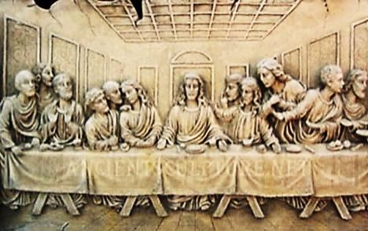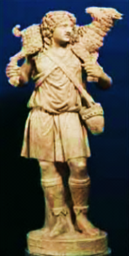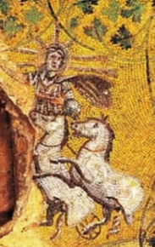
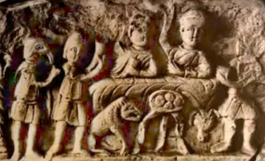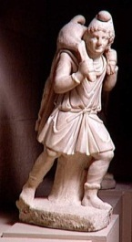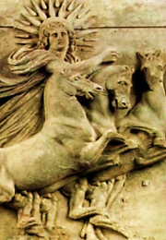
Figure 6: Compare the depictions Jesus (above) with those Mithras (below) and notice the amazing similarities in the last supper, the carriage of a lamb, and the riding a sun chariot. Don’t they reflect the influence of the pagan Mithraism on Christianity?

the Church destroyed most of them and selected only four Gospels written tens of years after Jesus, to be canonical.
Nonetheless, still, there are verses in the four canonical Gospels which still reflect the real nature of Jesus (PBUH) and his original message. These verses are coherent with the message preached by all the prophets of God who preceded Jesus and the message conveyed by the Prophet Muhammad (PBUT). In this section of the book, we will try to trace some of them.
5.1. God is one
Jesus in several verses in the Gospels emphasises that God is One God and not a triune God as claimed by the Church?
“The most important one answered Jesus, is this: ‘Hear, O Israel: The Lord our God, the Lord is one’” (Mark, 12:29).
“Now this is eternal life: that they know you, the only true God, and Jesus Christ, whom you have sent” (John, 17:3).
“How can you believe since you accept glory from one another but do not seek the glory that comes from the only God?” (John, 5:44).
“O Prophet (Muhammad) say: ‘I am but a man like you. It is revealed to me that your God is One God, therefore, take the Right Way towards Him and implore His forgiveness’. Woe to those who associate other gods with Him” (Qur’an, 41:6).
5.2. The fulfilment of the Law of God
Jesus (PBUH) was dedicated to the Law of God. He used to teach this Law in the temple and he commanded his followers to be committed to it. Please read the previous section 5.1in this booklet.
If Jesus had the least intention to destroy or abrogate the Law of God, as Apostle Paul claimed, why was he keen to keep and teach an obsolete Law every day?
“Each day, Jesus was teaching (the Law) at the temple” (Luke, 21:37).
Because Jesus (PBUH), like all the prophets of God, was dedicated to the Law of God he explicitly commanded his followers to stick to it and not even to think otherwise.
“Then We have put you (O Muhammad) on a plain pathway of commandment. So follow you that, and follow not the desires of those who do not know” (Qur’an, 45:18).
“When the believers are called to God and His Messenger to be judged, they say, ‘We hear and we obey’. And those are the successful” (Qur’an, 24:51).
“Do not think that I have come to abolish the Law (the Old Testament) or the Prophets; I have not come to abolish them but to fulfil them” (Matthew, 5:17).
“‘Why do you ask me about what is good?’ Jesus replied. ‘There is only One who is good. If you want to enter life, keep the commandments’” (Matthew,
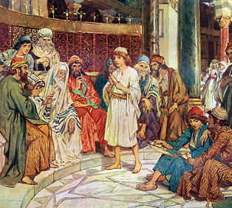 | 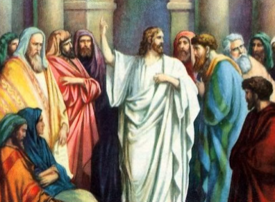
Figure 7: If Jesus (PBUH) was sent to abolish the Law of God or free Christians from it, what was the point of teaching it every day in the temple?

19:16-17).
The Qur’an affirms that Jesus Christ (PBUH) was sent to confirm the Law of God and so did the Prophet Muhammad (PBUH).
“And confirming (Jesus) what was before me of the Torah and to make lawful for you some of what was forbidden to you. And I have come to you with a sign from your Lord, so fear God and obey me” (Qur’an, 3:50).
“It is not for any believer, man or woman, when God and His Messenger have decided a matter, to have the liberty of choice in their decision. Whoever disobeys God and His Messenger has gone far astray” (Qur’an, 33:36).
5.3. Jesus was a prophet of God
All prophets were sent by God to guide their people to His Straight Path. Jesus (PBUH) made it clear that he was sent as a prophet to guide the lost sheep of the sons of Israel. Therefore, people at his time recognised him as a prophet of God.
“Truly, truly, I tell you, he who hears my word and believes him who sent me has eternal life” (John, 5:24).
“Jesus said to them, ‘A prophet is not without honour except in his hometown and in his own household’” (Matthew, 13:57).
“And the crowds said, ‘This is the prophet Jesus, from Nazareth of Galilee’” (Matthew, 21:11).
“Now this is eternal life: that they know you, the only true God, and Jesus Christ, whom you have sent” (John, 17:3).
“I tell you the truth, no servant is greater than his master, nor is a messenger greater than the One who sent him” (John, 13:16).
In the following verses, Jesus (PBUH) emphasised that the words he conveyed were God’s words and not his. Isn’t that the job of a prophet?
“These words you hear are not my own; they belong to the Father who sent me” (John, 14:24).
“The Messiah, the son of Mary, was no more than a messenger; many messengers had already passed away before him. His mother was a truthful woman” (Qur’an, 5:75).
“And We sent, following in their footsteps, Jesus, the son of Mary, confirming that which came before him in the Torah; and We gave him the Gospel, in which was guidance and light and confirming that which preceded it of the Torah as guidance and instruction for the righteous” (Qur’an,5:46).
5.4. Jesus was a man accredited by God
Jesus was recognised by people to be a man accredit
“Jesus of Nazareth was a man accredited by God to you by miracles, wonders, and signs, which God did among you through him, as you yourselves know” (Acts, 2:22).
“By myself, I can do nothing; I judge only as I hear, and my judgement is just, for I seek not to please myself but him who sent me” (John 5:30).
“Is there of your claimed partners of God, one who guides to the truth? Say: It is God Who guides to the truth. Is then He Who guides to the truth more worthy to be followed or he who finds no guidance unless he is guided?” (Qur’an, 10:35).
“They (Jesus and Mary) both used to eat food. Note how We make clear the revelations to them; then note how deluded they are” (Qur’an, 5:75).
“The likeness of Jesus in God’s sight is that of Adam: He created him from dust, and then said to him, ‘Be,’ and he was” (Qur’an, 3:59).
5.5. Jesus was not divine
5.5.1. “The Father is greater than I”
“I am going to the Father, for the Father is greater than I” (John, 14:28).
“Why do you call me good? No one is good, except God alone” (Mar, 10:18).
My Father, who has given them to me, is greater than all; no one can snatch them out of my Father's hand (John, 10:29).
“And (Jesus said) indeed, God is my Lord and your Lord, so worship Him. That is a straight path” (Qur’an, 19: 36).
5.5.2. Jesus was a servant of God
“The God of Abraham, Isaac, and Jacob, the God of our fathers, has glorified His servant Jesus” (Acts, 3:13).
“I tell you the truth, no servant is greater than his master, nor is a messenger greater than the One who sent him” (John, 13:16).
“Here is my servant (Jesus) whom I have chosen” (Matthew, 12:18).
Would God choose Himself or His eternal Son as a servant, or more logically He chooses His prophets to be His servants?
5.5.3. Jesus lacked knowledge and authority
“But about that day or hour no one knows, not even the angels in heaven, nor the Son, but only the Father” (Mark 13:32).
“For I have not spoken on my own authority, but the Father who sent me gave me command, what I should say and what I should speak” (John, 12:49).
If Jesses (PBUH) were divine, why did he lack knowledge and the authority?
5.5.4. Jesus’ divinity is based on false speculations
Christian scholars have claimed that some verses in the Gospels imply the divinity and eternity of Jesus (PBUH).
“In the beginning was the Word, and the Word was with God, and the Word was God. He was in the beginning with God. All things came into being through Him, and apart from Him, nothing came into being that has come into being” (John, 1:1-3).
“And now, Father, glorify me in your presence with the glory I had with you before the world began” (John, 17:5).
“I and the Father are one” (John, 10:30).
The notion of the first verses (John, 1:1-3) was stated by John and not by Jesus (PBUH). John was not an apostle or even an eyewitness of Jesus (PBUH). He wrote his Gospel about 100 years after Jesus and there is a possibility that he was influenced by the notions of Paul’s Epistles, which preceded his Gospel.
In addition, the original writings of John are not available, and therefore, one should not drop the possibility that “The false pen”, mentioned in Jeremiah (8:8), might have manipulated these verses. This might be confirmed by the fact that John in other verses, his Gospel, explicitly stated that God is one God (Read John, 5:44 and 17:3 in section 5.1).
The second verse could mean that God glorified Jesus as He did with all His prophets (PBUT) when He planned to create mankind and the world.
The third verse (John, 10:30) might imply that Jesus (PBUH) is one in purpose with God because he preached God’s Straight Path. That is why Jesus said, “As You, Father, are in me, and I in You; that they also may be one in us” (John 17:21). Definitely, “one’ in this verse means ‘one in purpose’.
“And they say: ‘The Most Merciful (God) has taken (for Himself) a son.’ Assuredly you utter a hideous thing, whereby almost the heavens are torn, and the earth is split asunder and the mountains fall in ruins; That they ascribe unto the Most Merciful a son, when it is not suitable for (the Majesty of) the Most Merciful that He should take a son” (Quran, 5:72).
5.6. Jesus’ miracles were done by the Will of God
It was by the Will of God that Jesus did his miracles. Therefore, Mark (8:22-26) tells us that he was not able to heal a blind man in the first attempt. Would God or son of God fail to heal a blind from the first attempt?
“But if I drive out demons by the finger of God, then the kingdom of God has come upon you” (Luke, 11:20).
“But if it is by the Spirit of God that I drive out demons, then the kingdom of God has come upon you” (Matthew, 12:28).
“Jesus of Nazareth was a man accredited by God to you by miracles, wonders, and signs, which God did among you through him, as you yourselves know” (Acts, 2:22).
“And He will teach him writing and wisdom and the Torah and the Gospel and [make him] a messenger to the Children of Israel, [who will say], ‘Indeed, I have come to you with a sign from your Lord in that I design for you from clay [that which is] like the form of a bird, then I breathe into it and it becomes a bird by permission of God. And I cure the blind and the leper, and I give life to the dead - by permission of God. And I inform you of what you eat and what you store in your houses. Indeed, in that is a sign for you, if you eat and what you store in your houses. Indeed, in that is a sign for you, if you are believers’” (Qur’an, 3:48-49).
Jesus (PBUH) admitted that he was capable of doing miracles by the help of God and not because he was divine. Interestingly, it was obvious for those who attended his miracles that he was a man supported by God (Acts, 2:22), and not God or son of God.
5.7. Everybody is responsible for his own deeds
According to today’s Christianity, Jesus suffered, died, buried, descended into hell, and rose from the dead, in order to grant eternal life and remission of sins of those who believe in him.
Where in the Bible, did Jesus say that he was God’s son who was sent to suffer for the remission of sins? On the contrary, in the Bible as in the Qur’an, everybody is responsible for his own deeds.
“The son shall not bear the iniquity of the father, neither shall the father bear the iniquity of the son: the righteousness of the righteous shall be upon him, and the wickedness of the wicked shall be upon him” (Ezekiel, 18:20).
“Fathers shall not be put to death for their children, nor children put to death for their fathers; each is to die for his own sin” (Deuteronomy, 24:16).
“No soul gets except what it is due, and no soul bears the burdens of another” (Qur’an, 6:164).
“Whoever is guided is only guided for (the benefit of) his soul. And whoever errs only errs against it. And no bearer of burdens will bear the burden of another. And never would We punish until We sent a messenger” (Qur’an, 17:15).
5.8. Love of Jesus necessitates his obedience
Jesus (PBUH) emphasised and commanded his followers, who love him, to obey his teachings and not to be misled by a false messiah, who might come after him even though he may perform great miracles and may be called an apostle.
“Anyone who does not love me will not obey my teaching. These words you hear are not my own; they belong to the Father who sent me” (John, 14:24).
“At that time if anyone says to you, ‘Look, here is the Messiah!’ Or, ‘There he is!’ Do not believe it. For false messiahs and false prophets will appear and perform great signs and wonders to deceive, if possible, even the elect. See, I have told you ahead of time” (Matthew, 24:23).
“Take heed that you are not led astray; for many will come in my name … Do not go after them” (Luke, 21:8).
“O you who believe! Obey God and obey the Messenger and those in authority among you. And if you dispute over anything, refer it to God and the Messenger, if you believe in God and the Last Day” (Qur’an, 4:59).
Is it fair after all these warnings of Jesus to follow a false messiah, like Paul, though he forsook the teachings of Jesus (PBUH)?
5. 9. Son of God is a metaphor
The term son of God, in the Bible, is used as a metaphor for prophets and even anyone who is righteous. Therefore, we find several sons of God in the Bible (Table 1).
In the following two verses, God considered David His sons. Did the Jews then consider David a divine son of God?
“I will proclaim the LORD's decree: He said to me, ‘You (David) are my son; today I have become your father’” (Psalms, 2:7).
“I will be his Father, and he shall be my Son” (1 Chronicles, 17:13).
Jesus (PBUH) clearly stated that God is his God and the God of his followers and God is his Father and the Father of his followers.
“I'm ascending to my Father and your Father, to my God and your God” (John, 20:17).
How could Jesus as a son of God and God have a God and why his followers were not considered divine though God is their father?
“And the Christians say: ‘the Messiah (Christ) is the son of God.’ That is what they say with their mouths, imitating the sayings of the former unbelievers” (Qur’an, 9:3).
“And they say, ‘The Most Merciful has begotten a son’. You have come up with something monstrous. At which the heavens almost rupture, and the earth splits, and the mountains fall and crumble because they attribute a son to the Most Merciful. It is not fitting for the Most Merciful to have a son. There is none in the heavens and the earth but will come to the Most Merciful as a servant” (Qur’an, 19:88-93).

Table 1: The term “son of God” is used to describe Angels, prophets and normal righteous people. It was commonly used among Jesus' people.
Jacob is God's son and firstborn | Exodus, 4:22
Solomon is God's son | 2 Samuel, 7:13-14, 1 Chronicles, 28: 6
Ephraim is God's firstborn | Jeremiah, 31:9
Adam is the son of God | Luke, 3:38
Common righteous people are sons of God | Deuteronomy, 14:1, Romans, 8:14, John, 1:12, Job 1:6, Genesis, 6:4, etc.
Angels are sons of God | Genesis, 6:2

6. Did Jesus practice Islam?
Jesus (PBUH) was born into a family of practising Jews who was consecrated to the service of God. Throughout his life, like all prophets of God, he preached one God (Please read 4.2 and 5.1 in this booklet). Believing in One God is essential in Islam.
“God does not forgive associating partners with Him, but He forgives anything less than that to whomever He wills. Whoever associates anything with God has devised a monstrous sin” (Qur’an, 4:38).
In addition, Jesus (PBUH) was committed to the Law of God and he taught it to “multitudes” of the lost sheep of Israel and commanded them to practically apply it. He even taught the law of God in the temple when he was young and before his mission. In his last speech, Jesus (PBUH), commanded his disciples to be committed to the law of God.
“If you love me you will keep my commandments” (John, 14:15).
By definition, believing in one God and the commitment to His Law is called Islam. Therefore, because, Muslims apply the Law of God they are the true followers of Jesus (PBUH).
6.1. Circumcision
God had an everlasting covenant with Abraham that males are to be circumcised.
“Any uncircumcised male, who has not been circumcised in the flesh, will be cut off from his people; he has broken my covenant” (Genesis, 17:14).
Therefore, Jesus was circumcised when he was eight days old (Luke, 2: 21;
1:59). Muhammad (PBUH), who is a descendant of Abraham through his son Ishmael and all Muslims keep the covenant of God and are all circumcised.
Would one claim to love Jesus (PBUH) and then follow Paul who broke the covenant of God with Abraham?
“Mark my words! I, Paul, tell you that if you let yourselves be circumcised, Christ will be of no value to you at all” (Galatians, 5:2).
6.2. Prayer
In his prayers, Jesus (PBUH) used to wash parts of his body (James, 4:8) and to physically bow or prostrate to God (Mathew 26:38), as Moses and Aaron did (Genesis, 17:3; Numbers, 20:6). Jesus (PBUH) never drew a sign of a cross on his body as some Christians do today. Muslims pray five times a day. Their prayer is preceded by ablution and they bow down and prostrate to God.
6.3. Jesus prohibited usury
“Do not take interest or any profit from them, but fear your God, so that they may continue to live among you” (Leviticus, 25:36).
“But love your enemies, and do good, and lend, expecting nothing in return” (Luke, 6:34-35).
Jesus (PBUH) respected the Law of God (Leviticus, 25:36) and regarded the charging of any interest for loans as sinful (Luke, 6:34-35). Muslims also respect the Law of God and do not take the interest.
However, unfortunately, this is not observed even by the Vatican itself which invests in interest-bearing schemes and requires Church administrators to do likewise (https://en.wikipedia.org/wiki/Usury#Usury_and_the_law, retrieved 6 August 2016).
6.4. Jesus did not drink wine
In John’s Bible (2:1-11), Jesus (PBUH) turned water into wine. However, this story seems to be a fabrication by the false pen (Jeremiah, 8:8).
First: The story was only mentioned in John’s Gospel.
Second: Jesus (PBUH) applied the Law of God and he knew that wine was a perpetual statute throughout generations.
“Do not drink wine or strong drink, neither you nor your sons ….it is a perpetual statute throughout your generations” (Leviticus 10:8-9).
“They ask you about intoxicants and gambling. Say, “There is gross sin in them” (Qur’an, 2:219).
Third: In this story, Jesus (PBUH) talked too rudely to his mother Mary. This does not befit with him and suggests that the story is a fabrication.
“O Woman, what has this to do with me?” (John 2:4).
“And (God) has made me (Jesus) blessed wherever I may be……and dutiful to my mother, and He did not make me a disobedient rebel” (Qur’an, 19:32).
Fourth: Even for the sake of argument, turning water into wine at the wedding does not mean that Jesus (PBUH) drank it.
6.5. Jesus did not eat pork
Pork is forbidden in the Old Testament. Jesus (PBUH) was committed to the Law of God, and therefore, he and his true followers, at his time, never consumed pork. Muslims also keep the Law of God and they never eat pork.
“You must not eat their meat or touch their carcases; they (pigs) are unclean for you” (Leviticus, 11: 8).
“Prohibited for you are carrion, blood, the flesh of swine, and animals dedicated to other than God” (Qur’an, 5:3).
However, Paul gave himself the authority to allow Christians to eat pork because they are no longer under the Law of God.
“For Christ is the end of the law for righteousness to everyone that believes” (Romans, 10:4).
6.6. Greetings
The greeting of Muslims is peace be upon you. This greeting was used by all the prophets of God like David (PBUH) (1 Samuel, 25:6).
The Jews use the word Shalom which means in the Hebrew language “Peace”. Jesus (PBUH) kept this tradition of greeting (John, 20:19, 21, 26; Luke, 24:36).
“While they were still talking about this, Jesus himself stood among them and said to them, ‘Peace be with you’” (Luke, 24:36).
6.7. Prayers and meditation in solitary
Jesus (PBUH) used to slip out to a solitary place like a mountain to pray (Matthew 14:23). He may even spend all the night praying and meditating (Luke, 6:12).
Praying in solitary was also practised by the Prophet Muhammad (PBUH) and by Muslims.
6.8. Jesus never bowed down to a cross or a statue
God has forbidden us to bow down to an idol, or any likeness.
“You shall not make for yourself an idol or any likeness of what is in heaven above or on the earth beneath or in the water under the earth. You shall not worship them or serve them” (Exodus, 20:4-5).
Therefore, Jesus (PBUH) never bowed down to a cross, a statue of Mary, or statues of saints as commonly practised by Christian.
7. How was Christianity falsified?
This was first initiated by Paul who preached religious teachings utterly different to those of Christ (PBUH). This twisted Pauline Christianity suited well Constantine I, the pagan Roman Emperor, who claimed his conversion to Christianity. The Church then compromised with Constantine and formulated the twisted Pauline Christianity that was enforced with the help of the powerful Emperor.
7.1. The role of Paul
Paul, as he described himself, in the New Testament, was a Jew and a powerful persecutor of Christians. After Jesus’s ascension, he claimed that he was converted to Christianity after seeing Jesus Christ (PBUH) in a vision. Interestingly, there are three contradictory accounts of the “story of Jesus (PBUH) appearing to Paul” in Acts, 9:3-17; 22:6-21 and 26:12-18. Don’t these contradictions raise doubt about the reliability of Paul’s vision?
Paul after his doubtful vision claimed that he had direct revelations from Jesus (PBUH) and appointed himself an apostle of Jesus (1 Corinthians, 1:1) in order to abolish Jesus’ teachings (PBUH) in his Epistles.
In order to attract new Gentiles converts, Paul used his knowledge of the Greek Stoic philosophy, to paganize Christianity. Therefore, Pauline Christianity was agreeable to the pagan gentiles and he was called, by the Church, “the Apostle of the Gentiles”. On the contrary, Paul was rejected by the true followers of Jesus Christ (PBUH).
Pauline Christianity is based on:
1) The divinity of Jesus (PBUH) as God and the incarnate son of God.
2) The concept of the original sin.
3) The atonement of sins through the suffering and death of Jesus (PBUH).
4) The Salvation through faith in Jesus (PBUH) and not works of God’s Law.
Table 2: Dates of conversion of Paul and the writing of his Epistles. Notice that the Epistles were written after two decades of his claimed conversion! Notice also that the Epistles preceded the writing of the four Gospels.
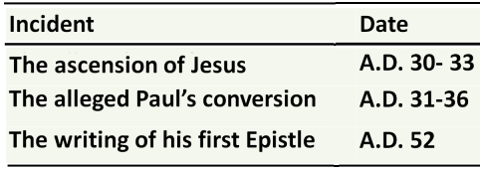  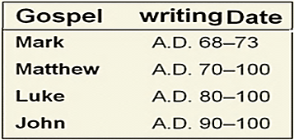 | 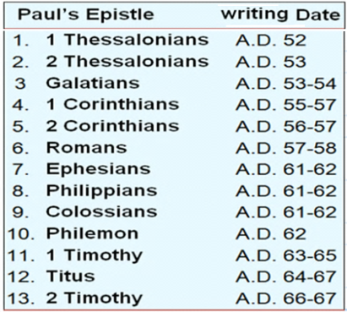

All these doctrines are innovations; they are not based on the teachings of Jesus and all the other prophets of God (PBUT).
Furthermore, as previously mentioned Paul clearly claimed that his version of Christianity was better than Jesus’ Christianity and considered both the Law of God and Jesus Christ (BUH) as curses (Please return to section 7.1 in this booklet).
Isn’t it obvious that Paul, the anti-Christ, claimed his conversion to Christianity in order to abolish the teachings of Jesus (PBUH) and destroy Christianity from within?
“Whoever then annuls one of the least of these commandments, and teaches others to do the same, shall be called least in the kingdom of heaven” (Matthew, 5:19).
Though Jesus (PBUH) warned from false messiahs like Paul, the Church has succeeded to mislead Christians to follow Paul.
“Watch out that no one deceives you. Many will come in my name, claiming, ‘I am he,’ and will deceive many” (Mark, 13:5-6).
“For false messiahs and false prophets will appear and perform great signs and wonders to deceive if possible even the elect” (Matthew, 24:24).
7.2. The role of Emperor Constantine I
The sun worshipper Roman Emperor, Constantine, claimed to have seen a vision, and accordingly he decided to become a Christian in AD 312. After his conversion to Christianity, as normally practised in Rome, Constantine became the Head of the Church, i.e. the “Pontiff Maximus”. This now is the title of the Pope of the Roman Catholic Church. Though Constantine is venerated as a great saint by Eastern Orthodox, Byzantine Catholics, and Anglicans, his conversion to Christianity is questionable.
- Constantine was baptised 25 years after his claimed conversion to Christianity when he was on his deathbed in AD 337.
- He did not make Christianity the state religion and allowed pagan religious festivals and practices.
- He continued to mint coins imprinted with his unconquerable sun god (Sol Invictus) (Figure 10).
- He substituted the Sabbath (Saturday) with Sunday (the day of his sun god) as the day of worship throughout the Roman Empire.
Why then did Emperor Constantine become a Christian?
Constantine was worried about his Roman Empire. He realised that his
vast Empire was ageing and needed desperately a survival element. He realised that the fast growing religion of Christianity can unify His Empire and give it the needed momentum.
Indeed Christianity strengthened his empire, however, after about a decade he discovered that the dispute about Jesus’ divinity could again threaten the unity of his Empire. Therefore, Constantine out of his political cleverness called for the Council of Nicaea, in 325AD, to resolve the theological controversy of Jesus’ divinity.
At the Council of Nicaea, Emperor Constantine presided over 300 church bishops and Church leaders and demanded them to define by a majority vote “who is Jesus Christ”?
To satisfy Constantine, who was inclined to Pauline Christianity, the Council of Nicaea overwhelmingly voted for the deity and eternity of Jesus Christ (PBUH) and affirmed the Trinity.
According to the Encyclopaedia Britannica: “Constantine himself presided, actively guiding the discussions, and personally proposed…the crucial formula expressing the relation of Christ to God in the creed issued by the council…Overawed by the emperor, the bishops, with two exceptions only, signed the creed, many of them much against their inclination” (1971 edition, Vol. 6, ‘Constantine’, p. 386).
Would one shape his faith according to a decision taken by voting in a Council called for and presided by an unbaptized pagan Emperor?
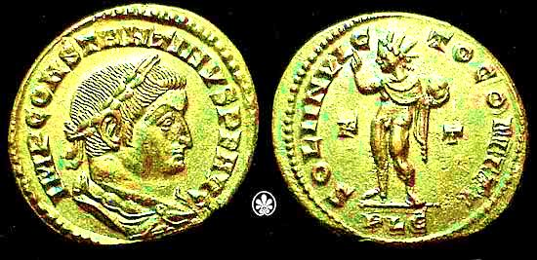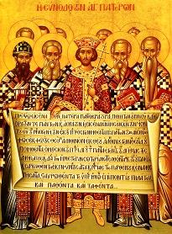
Figure 10: After Constantine’s conversion to Christianity, he continued to mend coins with his sun god (left). He called for the Nicaea Council (right) and used the Church to enforce the divinity of Jesus (PBUH).

7.3. The role of the Church
After centuries of debates and disputes, the Church, with the help of Emperor Constantine, succeeded to substitute Jesus’ Christianity with Pauline Christianity. The Triune nature of God the Father, God the Son and God the Holy Ghost was crystallised at the Councils of Nicea and Constantinople, which were held in AD 325 and 381, respectively.
The Bible with its 27 books of the New Testament was compiled by the Church and authorised at the end of the fourth century at the Councils of Carthage (AD 397). The Church tried to destroy all the genuine records of the Gospel, written in the Aramaic language of Jesus (PBUH) and the Gospels of Matthew, Mark, Luke, and John, which were written in the Greek language of Paul, were considered canonical. Those writers were not eyewitnesses of Jesus (PBUH) and wrote their Gospels between AD 65 and 110. This guaranteed that they were, at least to some extent, influenced by Paul’s Epistles, which were written earlier between 37 and 76 AD (Table 2).

In addition, to ensure the compatibility of the New Testament with the adopted Pauline Christianity, at least 13 of the compiled 27 books of the New Testament were written by Paul (Table 2).
8. Do you truly love Jesus?
8.1. You cannot love Jesus and follow Paul
God sent Jesus (PBUH) to guide people to His Straight Path. Therefore, Jesus’ teachings and not Paul’s teachings are the Straight path to God. You might, by now, have realised that you have been living a lie and you are actually holding Paul’s false teachings and not Jesus’ teachings?
“If you hold to my teaching, you are really my disciples” (John 8:31).
“And when God will say, “O Jesus son of Mary, did you say to the people, ‘Take me and my mother as gods rather than God?’ ‘He will say, “Glory be to You! It was not for me to say what I have no right to. Had I said it, You would have known it. You are the Knower of the hidden. I told them what You commanded me: that you shall worship God, my Lord and your Lord” (Qur’an, 5:116-117).
“O People of the Book! Why do you confound the truth with falsehood, and knowingly conceal the truth?” (Qur’an, 3:71).
“Say,’O People of the Scripture! Do not exaggerate in your religion beyond the truth, and do not follow the opinions of people who went astray before, and misled many, and themselves strayed far away from the right path’” (Qur’an, 5:77).

8.2. The guide to God’s Straight Path
Because the teachings of Jesus (PBUH) were twisted up by the Church and mixed up with Paul’s notions, and because God loves us and He wants us to hold to His Straight Path, He sent to us the Prophet Muhammad (PBUH).
The prophet Muhammad (PBUH) is a descendant of Abraham through his son Ishmael (PBUT). In the Bible, there are promises made by God to Abraham, and prophecies foretold by both Moses and Jesus about the advent of Muhammad (PBUT). More details are found in our book online “Restore your original religion” (http://www.islamic-invitation.com/book_details.php?bID=1790).
“O Prophet (Muhammad), Verily, We have sent you as a witness, a bearer of glad tidings and a Warner; and a preacher to God by His leave and a lamp spreading light” (Qur’an, 33:45-46).
8.3. Jesus’ prophecy about Muhammad
In his last speech, Jesus (PBUH), told his followers about the advent of the Paraclete and commanded them to follow him.
“And I will ask the Father, and he will give you another Paraclete that he may abide with you for ever” (John, 14:16).
“It is to your advantage that I go away, for if I do not go away, the Paraclete will not come to you; but if I go, I will send him to you (John, 16:7).
“When the Spirit of truth comes, he will guide you into all the truth; for he
will not speak on his own authority, but whatever he hears he will speak, and he will declare to you the things that are to come. He will glorify me, for he will take what is mine and declare it to you” (John, 16:13-14).
The Paraclete in the above verses was translated from the Old Koine Greek language by the Church as the counsellor, helper, encourager, advocate, or comforter, and was considered as the Holy Ghost which is the third head of the Trinity. However, the Paraclete is actually the Prophet Muhammad (PBUH) and not the Holy Ghost because:
- The term “Paraclete” means also praiseworthy, which is one of the names of the Prophet Muhammad (PBUH).
- “Another Paraclete” means that the Paraclete was going to be like Jesus (PBUH); i.e. a human and not a spirit.
- “If I do not go away, the Paraclete will not come”. The Holy Ghost was around at the time of Jesus (PBUH). For instance, he witnessed Jesus’ baptism (John 1:29-33). Therefore, the already existed and did not need to come after Jesus (PBUH).
- “That he may abide with you for ever”. The God’s Straight Path in the form of the Qur’an and the tradition of the Prophet Muhammad (PBUH) have been preserved meticulously to abide with us.
- “He will not speak on his own authority but whatever he hears he will speak”. According to the Trinity, the Holy Ghost is the third head of God, and therefore, he should have the full authority of God instead of hearing and conveying what he has heard. On the hand, the Prophet Muhammad (PBUH) heard the verses of the Qur’an from Angel Gabriel.
- “He will glorify me”: As a prophet of Islam, Jesus (PBUH) is mentioned 25 times in the Qur’an and more than 1.6 billion Muslims adore, love, respect, and glorify him. Whenever, Muslims hear his name they say peace be upon him.
- “He will take what is mine and declare it to you”: After the distortion of Christianity and the teachings of Jesus (PBUH) by Paul and the Church, it was Muhammad (PBUH) who brought back the teachings of Islam preached by Jesus (PBUH).
“Those who follow the Messenger, the unlettered prophet (Muhammad), whom they find written in what they have of the Torah and the Gospel, who enjoins upon them what is right and forbids them what is wrong and makes lawful for them the good things and prohibits for them the evil and relieves them of their burden and the shackles which were upon them. So they who have believed in him, honoured him, supported him and followed the light which was sent down with him - it is those who will be the successful” (Qur'an, 7:157).
8.4. If you love Jesus follow Muhammad - the Spirit of the Truth
If you truly believe in God and love Jesus (PBUH), set yourself free from the teachings of Paul and the Church and return to Jesus’ teachings.
“If you hold to my teaching, you are really my disciples. Then you will know the truth, and the truth will set you free” (John, 31-32).
If you love Jesus (PBUH), listen to his last command and believe in the Prophet Muhammad; the Spirit of truth, who affirmed Jesus’ teachings and brought back to you the Straight Path of God, which has been preserved exactly as it was revealed and guarantees your happiness in this life and the life to come.
“But when He, the Spirit of truth, comes, He will guide you into all the truth; for He will not speak on His own initiative, but whatever He hears, He will speak and He will disclose to you what is to come. He will glorify Me, for He will take of Mine and will disclose it to you” (John, 16:7-14).
“Say, ‘My Lord has guided me to a Straight Path, an upright religion, the creed of Abraham the Monotheist (believing in one God), who was not a polytheist (believing in more than one God)’.
Say, ‘My prayer and my worship, and my life and my death, are devoted to God, the Lord of the Worlds. No associate has Him. Thus, I am commanded, and I am the first of those who submit’.
Say, ‘Am I to seek a Lord other than God when He is the Lord of all things?’ No soul gets except what it is due, and no soul bears the burdens of another. Then to your Lord is your return, then He will inform you regarding your disputes” (Qur’an, 6:161-164).

DID
JESUS
PREACH ISLAM?

Muhammad solaiman

DID JESUS PREACH ISLAM?
Jesus (peace be upon him, PBUH) was sent like all the prophets of God to teach people that God is One and we should submit to His Law.
“The most important one answered Jesus, is this: ‘Hear, O Israel: The Lord our God, the Lord is one’” (Mark, 12:29).
“Do not think that I have come to abolish the Law or the Prophets; I have not come to abolish them but to fulfil them” (Matthew, 5:17).
However, after Jesus (PBUH), the anti-Christ Paul of Tarsus, who used to torture Christians, claimed his conversion to Christianity. In addition, he claimed to have had direct revelations from Jesus (PBUH), and hence, formulated a new Pauline Christianity.
According to Pauline Christianity, Jesus (PBUH) who was sent as a prophet of God, became the divine son of God who was sent as a ransom for the redemption of original sin of Adam and Eve. In addition, instead of fulfilling the law of God, Jesus (PBUH) was claimed to have freed Christians from it.
Regrettably, the Roman Emperor Constantine was inclined to Pauline Christianity and the Church adopted it to satisfy him and enforced it with his help. Therefore, what we have today is a Pauline Christianity and not the original Jesus’ Christianity
In this booklet, we provide, ample evidence, based on the Bible, that like all prophets, Jesus (PBUH) taught both the Oneness of God and the commitment to His Law, both of which are, by definition, called the religion of ISLAM.

